UBER RIDE ANALYSIS

Query 1 – Booking Status Distribution

Business Question:
What percentage of rides completed vs cancelled?

SELECT
Booking_Status,
COUNT(*) AS Total_Rides,
ROUND(COUNT(*) * 100.0 / SUM(COUNT(*)) OVER(), 2) AS Percentage
FROM uber
GROUP BY Booking_Status
ORDER BY Total_Rides DESC;

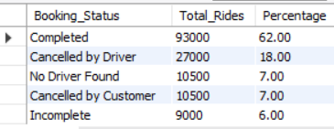

Insight:
Only 62% of rides completed. Driver cancellations (18%) are the single biggest failure reason — 3x higher than customer cancellations (7%).

Query 2 — Cancellation Reasons

Business Question:
Why are rides getting cancelled by customers and drivers?

Customer Cancellation

SELECT
Reason_for_Cancelling_by_Customer AS Cancellation_Reason,
COUNT(*) AS Total_Cancellations
FROM uber
WHERE Booking_Status = 'Cancelled by Customer'
GROUP BY Reason_for_Cancelling_by_Customer
ORDER BY Total_Cancellations DESC;

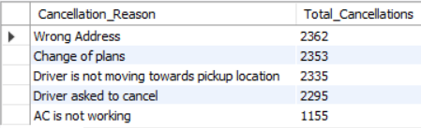

Driver Cancellation

SELECT
Driver_Cancellation_Reason AS Cancellation_Reason,
COUNT(*) AS Total_Cancellations
FROM uber
WHERE Booking_Status = 'Cancelled by Driver'
GROUP BY Driver_Cancellation_Reason
ORDER BY Total_Cancellations DESC;

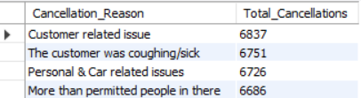

Insight:
On the Customer side, Wrong Address (2,362) tops customer cancellations, followed closely by Change of Plans (2,353) and Driver not moving to pickup (2,335). Notably, 2,295 "customer" cancellations were driver-requested.
On the Driver side, all four reasons are nearly equal (~6,700 each), pointing to systemic policy issues rather than any single cause.

Query 3 — Vehicle Type Analysis

Business Question:
Which vehicle type is most popular and how does booking completion rate vary across vehicle types?

SELECT
Vehicle_Type,
COUNT(*) AS Total_Bookings,
SUM(CASE WHEN Booking_Status = 'Completed' THEN 1 ELSE 0 END) AS Completed_Rides,
ROUND(SUM(CASE WHEN Booking_Status = 'Completed' THEN 1 ELSE 0 END) * 100.0 / COUNT(*), 2) AS Completion_Rate
FROM uber
GROUP BY Vehicle_Type
ORDER BY Total_Bookings DESC;

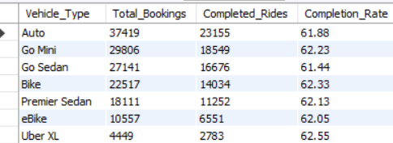

Insight:
Auto dominates with the highest bookings (37,419), followed by Go Mini (29,806) and Go Sedan (27,141), reflecting strong demand for affordable ride options. Completion rates are remarkably consistent across all vehicle types (~62%), suggesting cancellation issues are not vehicle-specific but rather systemic across the platform.

Query 4 — Revenue Analysis

Business Question:
Which vehicle type generates the most revenue and what is the average ride value?

SELECT
Vehicle_Type,
ROUND(SUM(Booking_Value), 2) AS Total_Revenue,
ROUND(AVG(Booking_Value), 2) AS Avg_Ride_Value
FROM uber
WHERE Booking_Status = 'Completed'
GROUP BY Vehicle_Type
ORDER BY Total_Revenue DESC;

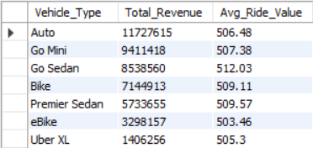

Insight:
Auto leads total revenue at ₹11.7M, followed by Go Mini (₹9.4M) and Go Sedan (₹8.5M) — directly reflecting their booking volumes. However, average ride value is nearly identical across all vehicle types (₹503–₹512), meaning no single vehicle type commands a premium fare, and revenue differences are driven purely by demand volume.

Query 5 — Driver Ratings Analysis
Business Question:
Which vehicle type has the highest and lowest driver ratings?

SELECT
Vehicle_Type,
ROUND(AVG(Driver_Ratings), 2) AS Avg_Driver_Rating,
ROUND(MIN(Driver_Ratings), 2) AS Min_Rating,
ROUND(MAX(Driver_Ratings), 2) AS Max_Rating
FROM uber
WHERE Booking_Status = 'Completed'
GROUP BY Vehicle_Type
ORDER BY Avg_Driver_Rating DESC;

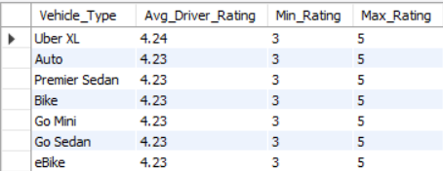

Insight:
Driver ratings are remarkably consistent across all vehicle types, averaging 4.23–4.24 out of 5. Uber XL edges slightly higher at 4.24, but the difference is negligible. All vehicle types share the same min (3) and max (5), indicating rating patterns are uniform platform-wide rather than vehicle-specific.

Query 6 — Peak Hours Analysis
Business Question:
At what times of the day is ride demand the highest?

SELECT
HOUR(Time) AS Hour_of_Day,
COUNT(*) AS Total_Bookings
FROM uber
GROUP BY HOUR(Time)
ORDER BY Total_Bookings DESC;

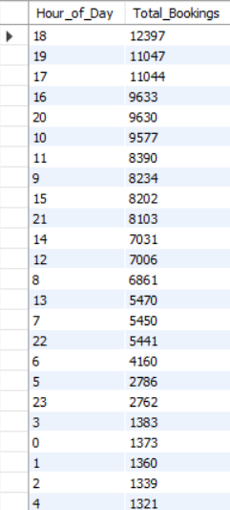

Insight:
Ride demand peaks sharply at 6 PM (12,397 bookings), followed by 7 PM (11,047) and 5 PM (11,044), clearly marking the evening office commute as the busiest period. A secondary peak is visible around 10–11 AM, likely reflecting mid-morning travel. Demand drops significantly after 10 PM and hits its lowest between 2–4 AM, suggesting a clear opportunity to incentivize drivers during evening rush hours.

Query 7 — Customer vs Driver Cancellation Rate

Business Question:
Who cancels more — customers or drivers?

SELECT
'Cancelled by Customer' AS Cancellation_Type,
COUNT(*) AS Total_Cancellations,
ROUND(COUNT(*) * 100.0 / (SELECT COUNT(*) FROM uber), 2) AS Cancellation_Rate
FROM uber
WHERE Booking_Status = 'Cancelled by Customer'

UNION ALL

SELECT
'Cancelled by Driver' AS Cancellation_Type,
COUNT(*) AS Total_Cancellations,
ROUND(COUNT(*) * 100.0 / (SELECT COUNT(*) FROM uber), 2) AS Cancellation_Rate
FROM uber
WHERE Booking_Status = 'Cancelled by Driver';

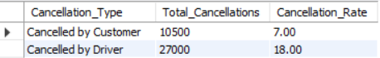

Insight:
Driver cancellations (27,000 — 18%) are significantly higher than customer cancellations (10,500 — 7%), making drivers 2.5x more likely to cancel a ride. This points to a clear supply-side problem where driver behavior is the dominant cancellation risk, directly impacting customer experience and platform reliability.

